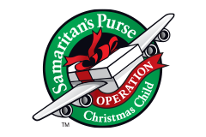
Girls Ages 2-4
NECESSARY ITEMS:
- Washrag
- Bar Soap
- Soap Holder
- Toothbrush
- Toothbrush holder
- Bandaids
- Qtips
- Comb/Brush
- Wipes

OPTIONAL ITEMS (in this box) Optional Replacement Items:
- Small Baby Dolls 1. Doll Clothes
- Coloring Book 2. Stuffed Animals
- Crayons 3. Small Purse
- Bouncy Ball
- Hair Bows
- Notepad
- Beach Ball
- Stickers

