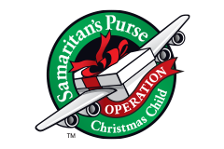
Girls Ages 10-14
NECESSARY ITEMS:
- Washrag
- Bar Soap
- Soap Holder
- Toothbrush
- Toothbrush holder
- Bandaids
- Qtips
- Comb/Brush
- Wipes
- Deodorant
- Always Liners
Optional Items: (in this box)
- Craft Sets (provided by church)
  - Room for this item needs to be accounted for.
- Pencils
- Pencil Sharpeners
- Erasers
- Ink Pens
- Glue Sticks Optional Replacement Items:
- Notepad 1. Stuffed Animals
- Jump Rope
- Toy Pom Poms
- Small makeup kit
- Small Cosmetic Bag
- Flashlight
- Batteries
- Hair Bows
- Toy Clackers

