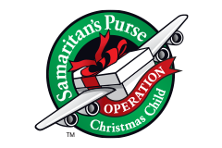
Boys Ages 5-9
NECESSARY ITEMS:
- Washrag
- Bar Soap
- Soap Holder
- Toothbrush
- Toothbrush holder
- Bandaids
- Qtips
- Comb/Brush
- Wipes

OPTIONAL ITEMS (in this box) Optional Replacement Items:
- Coloring Book 1. Small Soccer Ball (deflatable)
- Crayons 2. Small Air Pump and Needle
- Pencils (For Soccer Ball)
- Small Pencil Sharpeners
- Push on Erasers
- Ink Pens
- Glue Sticks
- Small Notepad
- Small Flashlight
- Batteries (for flashlight)
- Toy YoYo
- Bouncy Ball
- Toy Car
- Small Toy Football
- Beach Ball
- Toy Clacker

