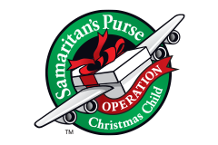
Boys Ages 10-14
NECESSARY ITEMS:
- Washrag
- Bar Soap
- Soap Holder
- Deodorant
- Toothbrush
- Toothbrush holder
- Bandaids
- Qtips
- Comb/Brush
- Wipes
- Pencils
- Pens
- Erasers
- Pencil Sharpeners
- Notepad
- Glue Sticks
OPTIONAL ITEMS (in this box) Optional Replacement Items:
- Screwdriver Set 1. 4X6 ft. tarp
- Pliers 2. Duct Tape
- Twine 3. Small Wrenches
- Bungee Straps 4. Small Soccer Ball (deflatable)
- Small Flashlight 5. Small air pump and needle
- Batteries (for flashlight) (For Soccer Ball)
- Work Gloves 6. Zip Ties
- Toy YoYo
- Bouncy Ball
- Toy Clacker
- Fishing Kit (will be provided by the church) Room for this needs to be accounted for.

